Dear Book Club Friend

I would like to invite you to take part in the Schoolreaders Book Club Quiz 2019. This will involve spending one of our forthcoming book club meetings doing a fun and informative quiz about books and reading. I hope that, at the same time, we can raise some funds for Schoolreaders.

Schoolreaders provides one-to-one support to primary school children who are struggling with their reading. They match volunteers to an appropriate local school, helping children improve their reading, gain confidence and increase their opportunities in later life. Schoolreaders is the only national charity to offer reading support to schools for free. This means that any child who needs support, regardless of the financial circumstances of their school, can benefit. While the Schoolreaders volunteers generously give their time for nothing, there are still costs associated with administering the scheme and the charity needs to raise vital funds so that more children who need reading support can be reached.

I would like to suggest that we take part in the Schoolreaders Book Club Quiz at our next meeting on:

Between us we might be able to crack the quiz, and we could win a tea with the author Catherine Alliott, some of whose 15 best-selling novels you may know\*. There are also lots of other fantastic prizes. I hope you agree that this is a great way to raise funds so that children can enjoy the benefits of reading as much as we all do.

Best wishes

www.schoolreaders.org

G0033

\* please see Quiz T&Cs on our website

Registered Charity: 1159157

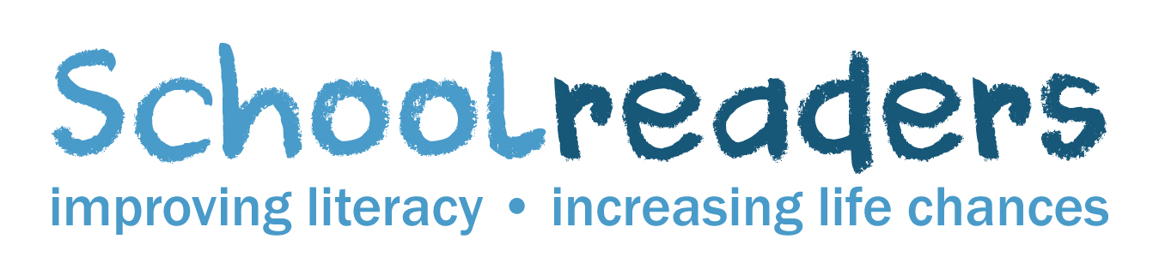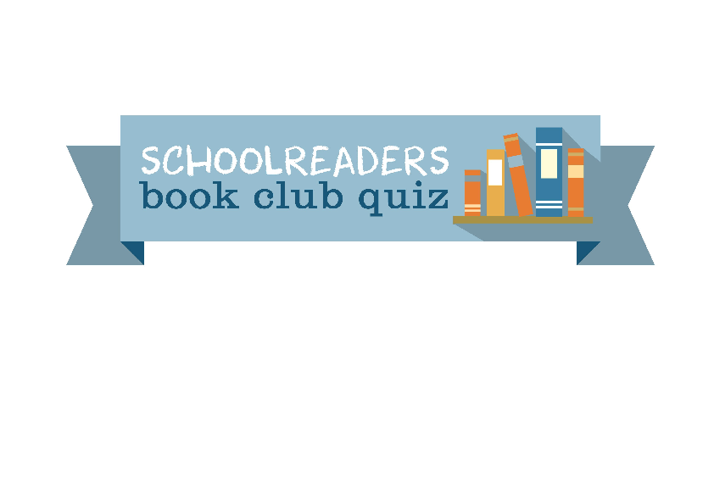

2019

to May

March